|  |  |
| --- | --- |
| **Date** | **16 November 2022** |
| **Team ID** | **PNT2022TMID26839** |
| **Project Name** | **PROJECT - SMART CROP PROTECTION SYSTEM FOR AGRICULTURE** |

**SPRINT 3**

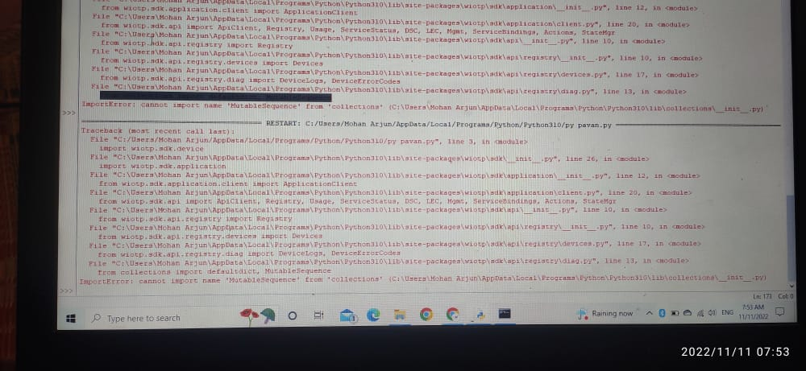

If I am clear all the error and final error it will create some import error